3M Circular Font Install instructions for Windows

Installing the new Trifecta fonts:
- Close all applications

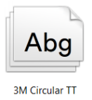
- Go to C:\Windows\Fonts
- Select and delete:

- Drag/copy the new fonts to your hard drive

- Select them and <right click> then choose “Install”

- Open Adobe and Microsoft programs to test the new 3M Circular TT font family.
- Adobe programs may ask you to find and replace fonts.
- Microsoft programs you may have to go to "Edit" menu to "Find/Replace Fonts" if any fonts default to Calibri font

